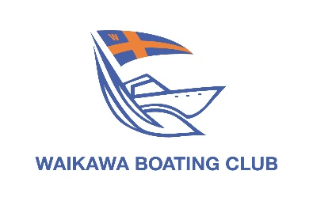
Notice of
Annual General Meeting
2.00pm 24 July 2021

The executive advise that the Annual General Meeting of the Waikawa Boating Club (Inc) will be held in the Clubhouse at 2.00pm on Saturday 24 July 2021.

Nominations for office are now open using the form below.
Additional nomination forms are available in the Clubhouse foyer.

Key Dates:
25 June 2021 Nominations for Executive Officers to be with the Club Manager by 5.00pm
25 June 2021 Notices of Motion to be with the Club Manager by 5.00pm
9 July 2021 Notices of Motion will be posted on the Clubhouse notice board
14 July 2021 Ballot papers posted to members (if required)
23 July 2021 Ballot papers to be returned to the Club Manager by 5.00pm
24 July 2021 Annual General Meeting

2021-2022 Executive Officer Nomination Form

I (proposer’s name & signature)

hereby nominate (candidate’s name)

seconded by (seconder’s name & signature)

for the position of

I accept the nomination (candidate’s signature)

Date

Executive Officer positions: Commodore, Vice Commodore, Rear Commodore Moorings & Assets, Rear Commodore Racing, Rear Commodore Cruising, Rear Commodore House, Executive Committee (3 positions), Health & Safety Officer.

Note:
- Candidate, proposer and seconder must be financial Full, Veteran or Life Members of Waikawa Boating Club
- Nominations and Notices of Motion must be received by the Club Manager no later than 5.00pm 25 June 2021
- Further information on Executive Officer role descriptions and the Club Constitution can be found on the website waikawaboatingclub.co.nz/annual-general-meeting/

